

Payment- customer

SYSTEM DESIGN DOCUMENT

Version 1.0

Confidentiality Statement

**This document contains information that is proprietary and confidential to Tata Consultancy Services Limited, which shall not be disclosed outside Transport for London, transmitted, or duplicated, used in whole or in part for any purpose other than its intended purpose. Any use or disclosure in whole or in part of this information without express written permission of Tata Consultancy Services is prohibited. Any other company and product names mentioned are used for identification purposes only and may be trademarks of their respective owners.**

**© Copyright <2021>, Tata Consultancy Services (TCS)**

TATA Code of Conduct

**We, in our dealings, are self-regulated by a code of conduct as enshrined in the ‘TATA Code of Conduct’. We request your support in helping us adhere to the code in letter and spirit. We request that any violation or potential violation of the code by any person be promptly brought to the notice of the Local Ethics Counsellor or the Principal Ethics Counsellors or the CEO of TCS. All communication received in this regard will be treated and kept as confidential.**

**Table 1: DOCUMENT REVISION LIST**

|  |  |  |  |
| --- | --- | --- | --- |
| Revision No. | Revision Date | Author | Revision Description |
| v1.0 | 26-Oct-2021 | Pranav Gandhi | This document covers payment process operated by customer |

CONTENTS

1 Introduction 7

1.1 Purpose 7

1.2 List of Abbreviations 7

1.3 Audience 8

2 Process Description 9

2.1 Payment 10

2.1.1 Pre-Requisite 10

2.1.2 Business Process Map 10

2.1.3 Form Specifications 11

2.1.4 Validations & Business Rules 18

2.1.5 Outcome of the Process 19

2.1.6 Open Items 19

**Table of Figures**

Figure 1: Business Process Map: Make Payment 10

Figure 2: Wireframe - Make Payment 12

Figure 3: Wireframe – Payment History 17

Figure 4: Wireframe – On Click of Pay Now - Pending Payment 17

Table of Tables

Table 1: DOCUMENT REVISION LIST 3

Table 2: List of Abbreviations 7

Table 3: Process and Sub-process List 9

Table 4: Form Specifications: Payment Details Screen 13

Table 5- Alert and Notifications – Payment Details Screen 14

Table 6- Business Rules and Validations- Payment Details Screen 15

Table 7-Form Specifications-View Payment Account 17

Table 8 - Alert and Notifications – View Payment Account 20

Table 9: Validations & Business Rules: View Payment Account 20

# Introduction

## Purpose

The objective of this document is to outline design for online payment process that will be initiated from Customer Portal. This document also illustrates the payment history and outstanding payment for a customer. Customer will make payment as per fees/charges configured for service for which customer is making payment. This document specifies Pre-Requisites, Business Process Maps associated with process, Form Specifications, Actions and Stakeholder details, Business Rules and Validations, Alerts and Notification, and Integration.

* Payment Details Screen
* View Payment Account

## List of Abbreviations

**Table 2: List of Abbreviations**

|  |  |
| --- | --- |
| Abbreviation | Expanded Form |
| TfL | Transport for London |
| TCS | Tata Consultancy Services Ltd. |
| TPH | Taxi and Private Hire |
| PHV | Private Hire Vehicle |

## Audience

This document is intended to provide an understanding on business functions to different teams:

* TfL Project Management
* TfL SME
* TCS Project team for Designing and developing Payment Process

# Process Description

The payment process is to capture the details of payment to be made against type of service selected by customer. This screen will be displayed to customer before submission of any request. Fees/charges defined for selected service will be displayed to customer. Customer needs to make payment using available payment methods. If payment made by customer is successful, then receipt will be generated. If payment is not successful, then customer will have option to initiate payment again and chose an alternative method for the online payment.

**Table 3: Process and Sub-process List**

|  |  |  |  |  |
| --- | --- | --- | --- | --- |
| **Process** | | **Application** | | **Description** |
| 1 | Payment Details | Payment Details Screen | Online | This screen will come for customer before submitting any request in which payment needs to be made. Details of calculated fees will be shown to customer. Once customer clicks on Proceed for payment then the redirection would happen on payment gateway screen. |
| View Payment Account | Online | Details of outstanding payments should be shown to customer. This will cover total amount paid till date, outstanding amount till date. For outstanding amount services wise and fee type wise details also should be displayed. Customer can search details based on date, licence type and licence number etc. |

## Payment

This Process will be available at Customer portal. Payment details defined for selected service will be displayed to customer. Customer needs to make payment before submission of application. Customer will choose available payment method for making payment. If payment made by customer is successful, then receipt will be generated. If payment is not successful, then customer will be notified over PMOC to make online payment using alternative method.

### Pre-Requisite

* Customer should hold an active and valid customer account.
* Fees/Charges should be configured for different services.
* Application should be completed for submission.

### Business Process Map

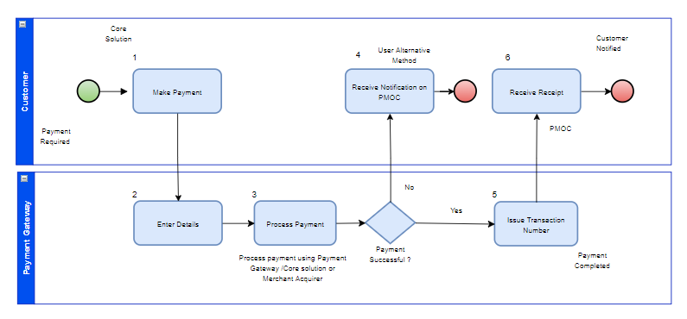

**Figure 1: Business Process Map: Make Payment**

**Process Flow Description**

* System prompt payment requirement to customer.
* Customer will be navigated to choose payment method for making requested payment.
* Customer will make payment as per charges/fees defined for type of service.
* If payment details are proper, then payment will be processed as per payment mode selected by customer.
* If Payment is not successful for payment mode selected by customer then system will notify customer over PMOC to make payment from alternative payment method.
* If payment is successful, then receipt will be issued customer.

### Form Specifications

This section describes form specifications for apply for driver licence PHV process. Form specification contains following attributes:

**Field Name** – Indicates name of the field

**Field Type** – Indicates Data Type of field e.g., Textbox, Label, Datebox, Dropdown etc.

**Field Length** – Indicates Length of the field

**Description** – Details like brief description, condition, information etc.

**M/ O/ C/ A** – Indicates field is Mandatory, Optional, Conditional or Auto-populated

#### Form: Payment Details Screen

This form will be available at customer online portal. This form will be available to customer before submitting any request in which payment needs to be made. Details calculated fees will be shown to customer. Once customer clicks on Proceed for payment then the redirection would happen on payment gateway screen.

**Table 4: Form Specifications: Payment Details Screen**

|  |  |  |  |  |  |  |
| --- | --- | --- | --- | --- | --- | --- |
| **Sub-Section** | **Field Name** | **Field Type** | **Field Length** | **Description** | **M/O/C/A** | **Remarks** |
| ***Payment Details*** | Process Name | Label |  | Process Name will be auto populated based on redirection from the process. It will be like Apply for Driver Licence – PHV, Apply for Operator Licence | A |  |
| Fees Details |  |  | This will be displayed as table with Selection Checkbox, Sr. No., Fee Type, Amount. Customer will have an option to select fee type based on rules set for various processes | A |  |

##### **Visual Design/ Wireframe/ User Interface**

Wireframes can be viewed at:

https://xd.adobe.com/view/e9cc0085-7762-4839-ae25-153e062f386c-bc9f/screen/c5185125-b486-4ce3-ac86-f31cf7e6fda4?fullscreen

**Figure 2: Wireframe - Make Payment**

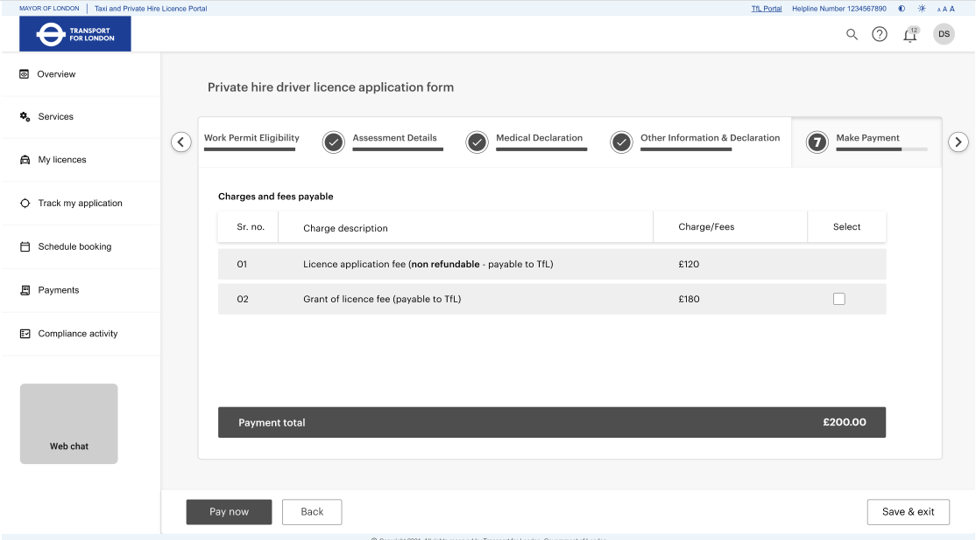

##### **Actions & Stakeholders**

**Stakeholder**: Customer

**Actions**:

**Proceed to Payment:** - On click of proceed to payment button, customer will be redirected to

payment gateway page where customer can choose payment method for making payment.

**Close: -** Payment page will be closed.

##### **Alert and Notifications**

**Notification**

**Table 5- Alert and Notifications – Payment Details Screen**

|  |  |  |  |
| --- | --- | --- | --- |
| **Channel** | **Notification** | **Trigger Event** | **Notified To** |
| PMOC | Your payment is successful | If payment is successful | Customer |
| PMOC | You can view/download your receipt from view receipt link | If payment is successful | Customer |
| PMOC | Your payment is unsuccessful. You are requested to make payment from alternative payment method. | If payment is not successful | Customer |

##### **Business Rules and Validations**

**Table 6- Business Rules and Validations- Payment Details Screen**

|  |  |  |
| --- | --- | --- |
| **Sr. No.** | **Business Rules** | **Remarks** |
|  | To proceed in the next stage of any part of a licensing application (new/renewals/variations), payment made by an applicant must be valid. |  |
|  | Full payments of either the full Application Fee or the Grant of Licence Fee (GoL) taken must be reconciled against the specific record (driver/vehicle/operator applicant or licensee for any relevant process) to proceed to the next stage of the application. |  |

##### **Integration**

**External Integration**

* Payment Gateway

#### Form: View Payment Account

This form will be available at customer portal. Details of

1. Payments Made
2. Outstanding payments will be shown to customer. This will cover amount paid till date, outstanding amount. For outstanding amount services wise and fee type wise details also should be displayed. Customer can search details based on date, licence type and licence number etc. The Outstanding payments may include:
   1. Fee like Licence Issuance Fee which becomes due as part of the process and not paid upfront.
   2. Due Instalments
   3. Chargeback Transactions or Refund of a valid transaction.

##### **Form Details**

**Table 7-Form Specifications-View Payment Account**

|  |  |  |  |  |  |  |
| --- | --- | --- | --- | --- | --- | --- |
| **Sub-Section** | **Field Name** | **Field Type** | **Field Length** | **Description** | **M/O/C/A** | **Remarks** |
| ***Search*** | Transaction Reference Number | Textbox |  | User will enter Transaction Reference Number | O |  |
| Application/Licence Reference Number | Textbox |  | User will enter Application/Licence Reference Number | O |  |
| Date Range | Date |  | User will select From and To Date Range for Search | O |  |
| Process Name | Dropdown |  | User will select the Process Name or All | O |  |
| Search Button |  |  | User will search by entering above criteria |  |  |
| ***Account Details*** | Amount Paid till date | Label |  | Total Amount Paid till date |  |  |
| Outstanding Amount | Label |  | Outstanding amount will be displayed. (All Fee Due or instalments that have not been paid or Chargeback valid payments) |  |  |
| ***Pending Payments*** | Reference Number | Label |  | Application Reference Number |  |  |
| Amount | Label |  | Amount Due |  |  |
| Pay Now | Button |  |  |  |  |
| ***Payment History*** | Serial Number | Label |  |  |  | Sequential Serial Number |
| Reference Number | Label |  | Application /licence reference number |  |  |
| Application/Licence Type | Label |  | Application/licence type for which payment is made |  |  |
| Transaction Number | Label |  | Denotes Transaction Reference number |  |  |
| Transaction Type | Label |  | Denotes Transaction Type like Payment, Refund, Chargeback. |  |  |
| Amount | Label |  | Fee (Amount) paid |  |  |
| Date and Time | Label |  | Transaction date and time |  |  |
| Mode of Payment | Label |  | This denotes mode of payment  Online  Check and Send  Scan and Print Partner |  |  |
| Transaction Status | Label |  | The Status of the payment shall be shown like:  Success  Failed  In-Process |  |  |
| Action | Label |  | 1. Pay Instalment 2. View/Download Receipt 3. Retry |  |  |

##### **Visual Design/ Wireframe/ User Interface**

Wireframes can be viewed at:

<https://xd.adobe.com/view/c78a5457-05b5-4b76-88fd-4ffe953abc46-92d9/screen/d74d8a87-75ac-43d9-82e6-f488b599e717/?fullscreen>

**Figure 3: Wireframe – Payment History**

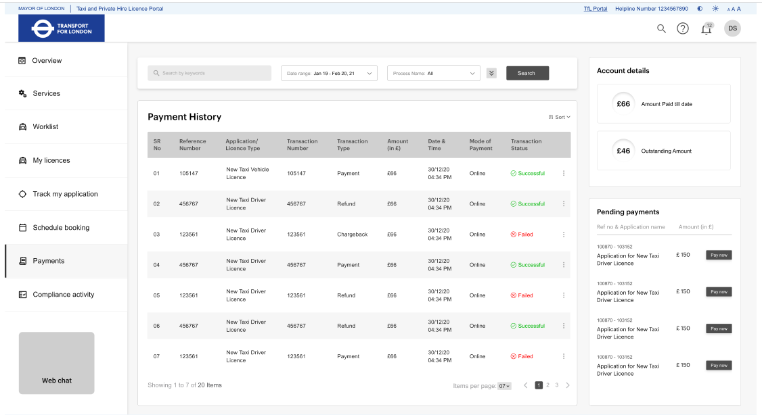

**Figure 4: Wireframe – On Click of Pay Now - Pending Payment**

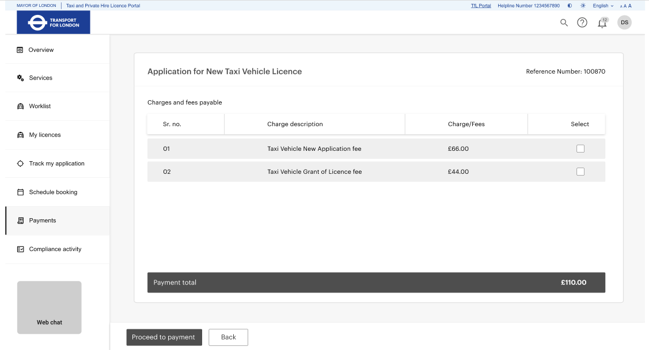

##### **Actions and Stakeholders**

**Stakeholder**: Customer

**Actions**:

**View/Download Receipt**: - On click the user will be able to view and download receipt.

**Pay Instalment:** - On click of proceed to payment button, customer will be redirected to

payment gateway page where customer can choose payment method for making payment for selected payment option to pay for instalment amount)

**Retry**: - This Option shall be available only when the Payment Status is In-Process or response from the Payment gateway has not been received and the user needs to try again for Payment. On click of this Option the transaction status shall be updated as either Success or Failed. If Failed, then the user will be able to pay again and be navigated to the application’s proceed to payment.

##### **Alerts and Notifications**

**Notification**

**Table 8 - Alert and Notifications – View Payment Account**

|  |  |  |  |
| --- | --- | --- | --- |
| **Channel** | **Notification** | **Trigger Event** | **Notified To** |
| PMOC | Your payment is successful | If payment is successful | Customer |
| PMOC | You can view/download your receipt from view receipt link | If payment is successful | Customer |
| PMOC | Your payment is unsuccessful. You are requested to make payment from alternative payment method. | If payment is not successful | Customer |

##### **Integration**

**External Integration**

* Payment Gateway

### Validations & Business Rules

**Table 9: Validations & Business Rules: View Payment Account**

|  |  |  |
| --- | --- | --- |
| Sr. No. | Business Rules | Remarks |
| 1 | All the mandatory validations mentioned on form level  should be performed and highlighted. In case of all  validation is proper then Application number will be  generated and displayed on screen. |  |

### Outcome of the Process

* Payment receipt will be generated on successful payment.
* Payment reference number will be generated on successful payment.

### Open Items

**Following list of items are open for inputs:**

1. **Format for Payment Reference Number and Payment receipt template/layout.**